WEEK II ASSIGNMENT
Query 1. Display the entire dataset imported as csv file
SELECT * FROM mydb.sales;
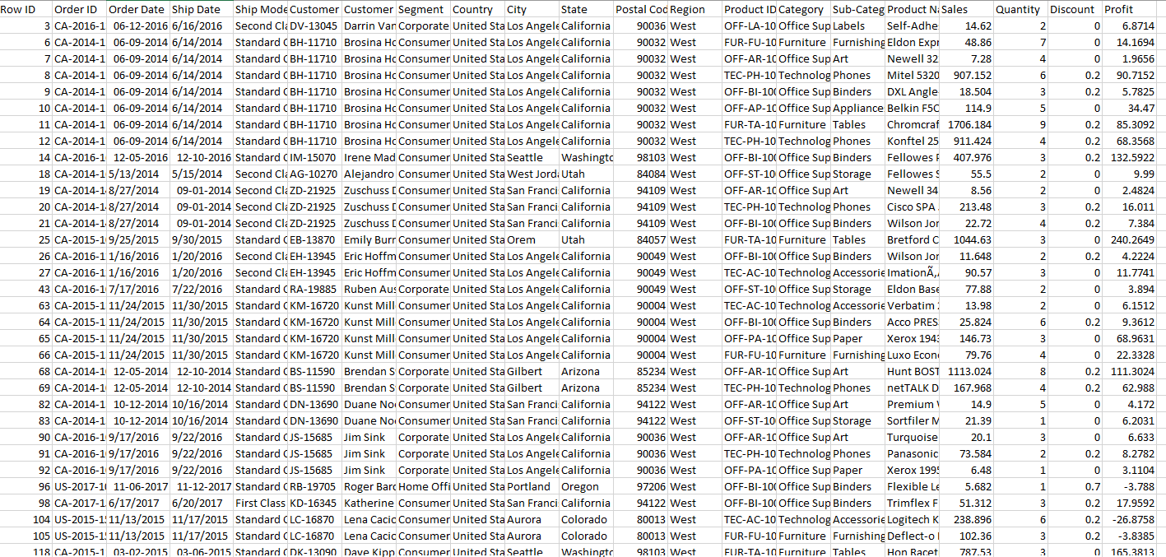
Query 2. Display those column in dataset that are in the region south
SELECT *
FROM mydb.sales
WHERE Region = 'South';
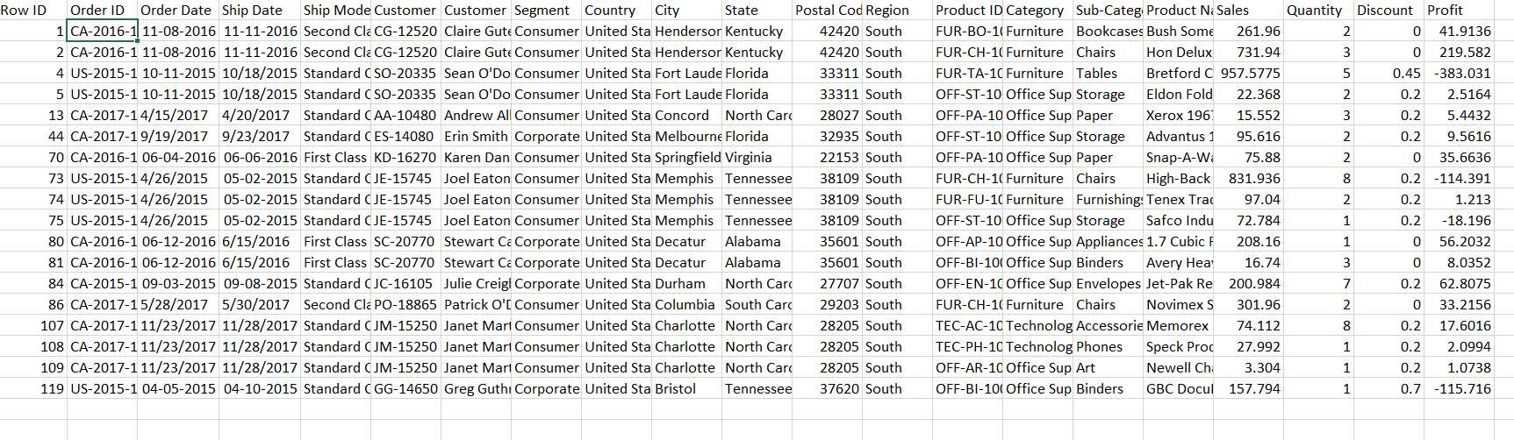
Query 3. Display those column in dataset whose category is furniture
SELECT *
FROM mydb.sales
WHERE Category = 'Furniture';
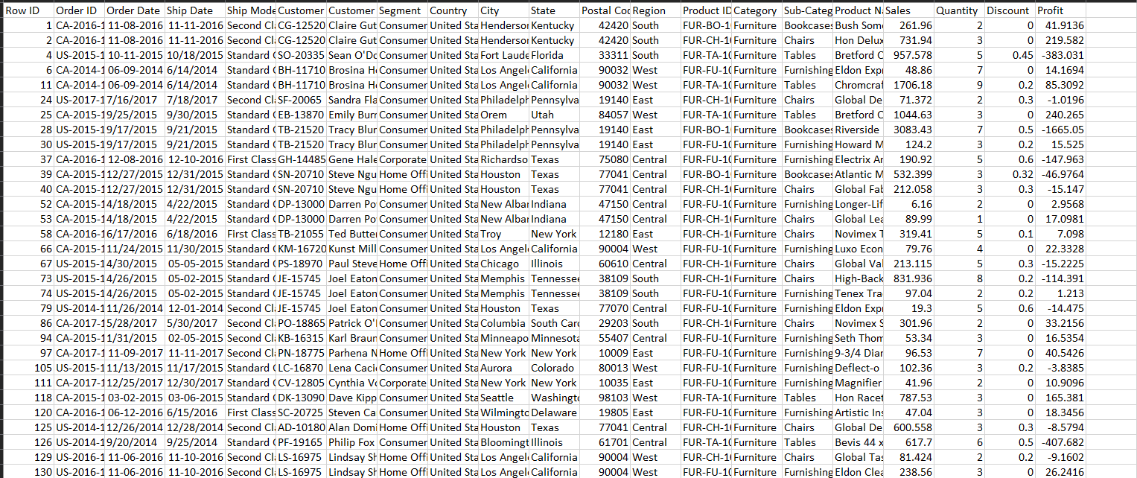
Query 4. Display those column in dataset whose sales is greater than 2000
SELECT *
FROM mydb.sales
WHERE Sales > 2000;
Query 5. Display those column in dataset whose order date is after 2011-01-01
SELECT *
FROM mydb.sales
WHERE `Order Date` > '2011-01-01';
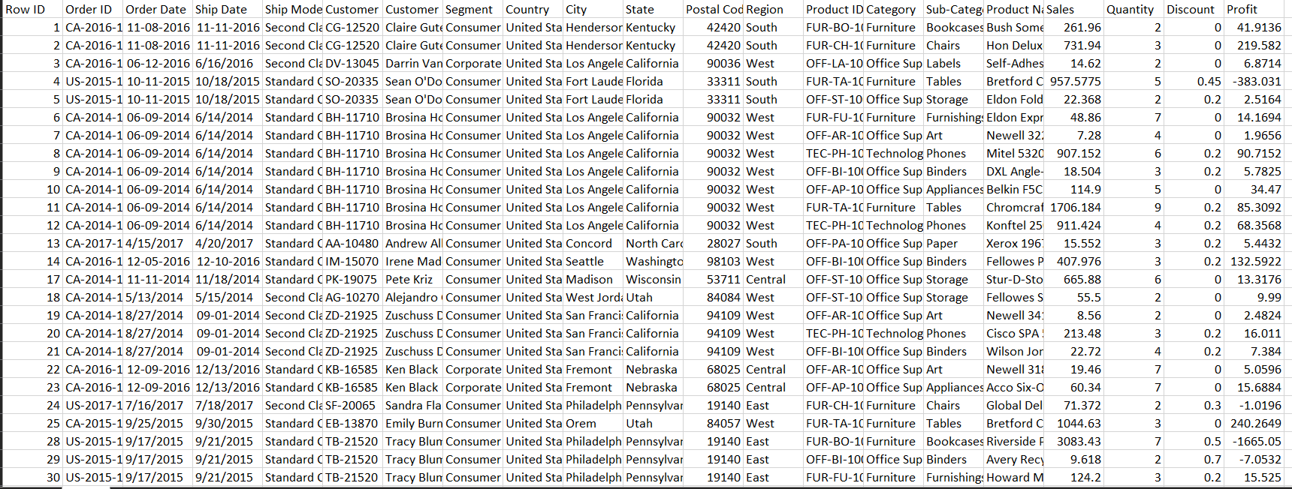
Query 6. Performing the aggregation function like sum(), max(), avg() on sales column of the dataset
SELECT SUM(Sales) AS Total_Sales
FROM mydb.sales;
SELECT MAX(Sales) AS Highest_Sale
FROM mydb.sales;
SELECT AVG(Sales) AS Average_Sales
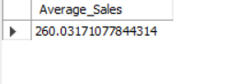
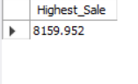
FROM mydb.sales;
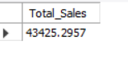
Query 7. Performing the group by clause to display the selected row and columns of the dataset
SELECT
Region, SUM(Sales) AS Total_Sales
FROM
mydb.sales
GROUP BY Region;

SELECT Category,
AVG(Sales) AS Average_Sales
FROM mydb.sales
GROUP BY Category;
SELECT Region,
SUM(Quantity) AS Quantity_Sold
FROM mydb.sales
GROUP BY Region;
SELECT Category,
COUNT(*) AS Orders
FROM mydb.sales
GROUP BY Category;
SELECT `Customer Name`,
SUM(Quantity) AS Quantity
FROM mydb.sales
GROUP BY `Customer Name`
HAVING SUM(Quantity)>10;
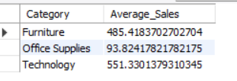
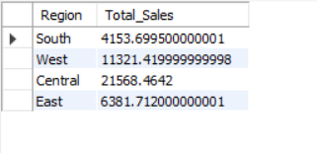
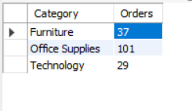
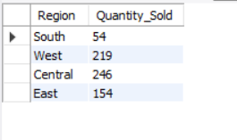

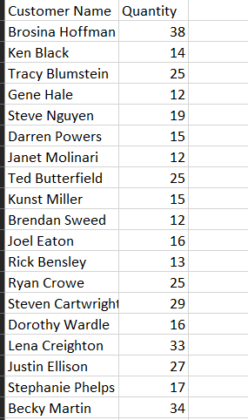

Query 8. Performing the limit and order by clause to display the selected row and columns of the dataset to display the top 10 performs of the dataset
SELECT `Customer Name`,
SUM(Sales) AS Total_Sales
FROM mydb.sales
GROUP BY `Customer Name`
ORDER BY Total_Sales DESC
LIMIT 10;
SELECT Region,
SUM(Profit) AS Profit
FROM mydb.sales
GROUP BY Region
ORDER BY Profit DESC;
SELECT `Product Name`,
SUM(Sales) AS Total_Sales
FROM mydb.sales
GROUP BY `Product Name`
ORDER BY Total_Sales DESC
LIMIT 10;
